
Do-It-Yourself CEO Job Descriptions
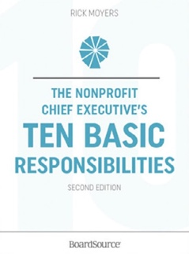
Available in print or PDF at www.BoardSource.org

The Nonprofit Chief Executive’s
Ten Basic Responsibilities, Second Edition Rick Moyers

10 Basic Responsibilities of Nonprofit CEOs |  | ☑ If this is included in your current CEO position description.  ⊠ Note any action steps required.
1 | Commit to the mission
2 | Lead the staff and manage the organization
3 | Exercise responsible financial stewardship
4 | Lead and manage fundraising
5 | Follow the highest ethical standards, ensure accountability, and comply with the law
6 | Engage the board in planning and lead implementation
7 | Develop future leadership
8 | Build external relationships and serve as an advocate
9 | Ensure the quality and effectiveness of programs
10 | Support the board

Download the book’s “Table of Contents” and “Introduction” here:
https://boardsource.org/wp-content/uploads/2016/10/Nonprofit-CEO-Ten-Basic-Responsibilities-TOC-1.pdf

CEO Job Description Homework:
We would add these additional basic responsibilities—based on our history, our culture, our faith-based convictions, the season/cycle we’re in, and other factors:
Additional Basic Responsibilities of Our
Nonprofit CEO
11
12
13
14
15
IMPORTANT! Job descriptions are helpful, but you’ll find the most helpful document for effective CEO/board relationships (and the growth of your organization) will be when you have agreement on the CEO’s 3 to 5 Annual S.M.A.R.T. Goals. (See Tool #11.)
Ten Questions for Nonprofit CEOs Question 6:
Do you know who your next board chair is likely to be?
- Yes
- No
- Are you kidding? 2

Rick Moyers, The Nonprofit Chief Executive’s Ten Basic Responsibilities, 2d ed. (Washington, DC: BoardSource, 2013).
Ibid., 60.

