[](http://www.ecfa.org/ToolsAndTemplates/Tool_18_Job_Descriptions_TopLeader_BoardChair.pdf)

### ECFA Knowledge Center [www.ECFA.org](http://www.ECFA.org/)

Used by Permission

# Sample Board Chair Position Description

## **Authority for Electing the Board Chair**

The bylaws of [Name of Ministry] stipulate that the board of directors shall annually elect a Board Chair. (Note: The bylaws may provide for an election cycle other than an annual election.)

## **Qualifications**

Completed two years of board membership term and have an understanding of parliamentary procedures.

## **Term**

The Chair is elected by the board for a one-year term in accordance with the bylaws.

## **Requirements:**

* Commitment to the work of the ministry;
* Knowledge and skills in one or more areas of board governance: policy, finance, programs, and/or personnel;
* Regular attendance at periodic board meetings;
* Prepare for, and participate in, the discussions and the deliberations of the board;
* Foster a positive working relationship with other board members and the organization’s staff; and
* Be aware of, and abstain from, any real or perceived conflicts of interest

## **Major Duties:**

* Be the primary spokesperson for [Name of Ministry] to the media and the community at large;
* Chair the Executive Committee (if there is one);
* Report to the board on the status of major programs;
* Signing authority on behalf of the board for financial and legal purposes;
* Provide leadership and direction to the board;
* Arrange for Vice Chair to chair meetings when absent;
* In conjunction with the CEO, set the periodic board meeting agenda;
* Ensure board members receive agenda and minutes in a timely manner; and
* Adhere to general duties outlined in the board member job description

# Do-It-Yourself Board Chair Job Descriptions

Wordsmith your own job description from “McKenna’s 9 M’s”

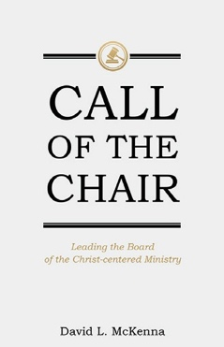

### Call of the Chair:

***Leading the Board of the Christ-Centered Ministry***

by David L. McKenna

Read the review:

[*http://urgentink.typepad.com/my_weblog/2017/06/call-of-the-chair.html*](http://urgentink.typepad.com/my_weblog/2017/06/call-of-the-chair.html)

|  |  |  |
| --- | --- | --- |
| **No.** | **McKenna’s 9 Ms** | **Per McKenna, the “distinctive role of the board chair for the Christ-centered ministry” is answered this way:** |
| **1** | Missionary |  |
| **2** | Model |  |
| **3** | Mentor |  |
| **4** | Manager |  |
| **5** | Moderator |  |
| **6** | Mediator |  |
| **7** | Monitor |  |
| **8** | Master |  |
| **9** | Maestro |  |