# The Rolling 3-Year Strategic Plan Placemat (1-Page Tool)

See sample 11” x 17” (landscape format) strategic plan placemat example on next page ➞

**Download the template for “The Rolling 3-Year Strategic Plan Placemat.” We recommend:**

* 11” x 17” landscape on high quality paper
* Full-color placemat provided to every board member and staff member
* Enlarged version displayed in boardroom and lunchroom
* Select a Bible verse that summarizes your aspirations.

# XYZ International’s Strategic Plan: 2020 – 2022

“Commit your actions to the Lord, and your plans will success.” (Proverbs 16:3 NLT)

|  |  |
| --- | --- |
| **(Logo here)** | **(Slogan here)** |
| **MISSION**  Why we exist. | Our mission is to… |
| **VALUES**  How we will treat each other and our constituents. | We value: |
| **VISION**  What we want to be in the future. | Our vision is to… |
| **BHAG**  Not achievable without God’s unique blessing. | By ______, 2022, our Big HOLY Audacious Goal is to…  *Note:* The BHAG should be written as a “SMART Goal” and be measurable, memorable, and succinct. (For balance, read *The Choice: The Christ-Centered Pursuit of Kingdom Outcomes*,[1] and Lesson 37 in *Lessons From the Nonprofit Boardroom*, “Don’t Stretch Credulity With BHAGs and Stretch Goals.” The actual achievement of audacious goals is very uncommon.”[2] |

|  |  |  |  |  |
| --- | --- | --- | --- | --- |
| **Visionary Priorities**  (S.M.A.R.T. Goals) | Year 1:  **2020** | Year 2:  **2021** | Year 3:  **2022** | Add **2023**  by 11/15/2020 |
| #1: (verb)…  **TO BUILD a…** |  |  |  |  |
| #2: (verb)…  **TO CREATE a…** |  |  |  |  |
| #3: (verb)…  **TO ENRICH a…** |  |  |  |  |

Version 1.0 (Nov. 15, 2019). This Rolling 3-Year Strategic Plan Placemat is updated annually by November 15 and is ready for board approval at the year-end board meeting. **S.M.A.R.T. Goals** are: **S**pecific, **M**easurable, **A**chievable, **R**ealistic, and **T**ime-related.

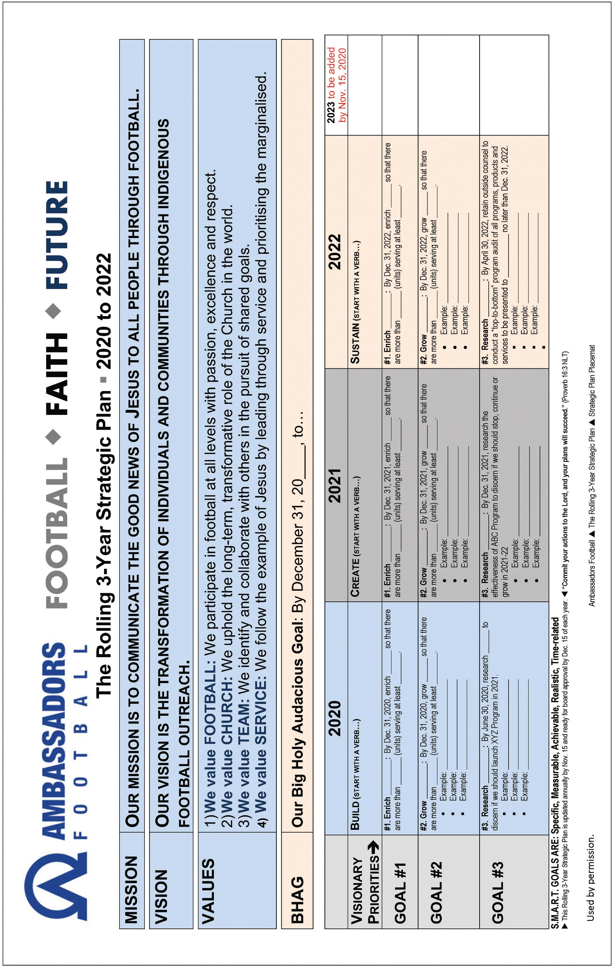

**Strategic Plan Placemat: 11” x 17” (landscape format)**

**EXAMPLE ONLY:** The template on the previous page is just that—a template. Use the categories, if helpful, or create your own categories. If possible, begin each goal with a VERB (enrich, grow, research, engage, retain, abandon, pray, train, build, etc.). The final approved version will be the one-page summary of other documents, often including a supplementary document with 3-5 “S.M.A.R.T. Goals” for every team member. And…you’re NOT done until you have created monthly “dashboard” reporting templates (See Tool #11.)

**Ambassadors Football** (Example Only: Used by permission.)

|  |  |
| --- | --- |
|  | **Year 1: 2020** |
| **Visionary Priorities**➡ | **BUILD A GLOBAL EVANGELISM MOVEMENT BY INSPIRING AND EQUIPPING 35 COUNTRIES WITH AMBASSADORS FOOTBALL EXPERTISE AND RESOURCES BY DEC. 31, 2022.** |
| **GOAL #1** | **#1. Enrich Current Country Relationships:** By Dec. 31, 2020, enrich the international work and scope of AF so that all 25 country leaders (and their indigenous boards) rate AF support and services at 4.0 on a scale of 1 to 5 (5.0 is excellent). |
| **GOAL #2** | **#2. Grow by 3 Countries:** By Dec. 31, 2020, welcome at least 3 new country relationships (for a total of 28 total countries)—and affirm that the new countries have met the criteria per the “XYZ Relationship” document, to include:   * Indigenous board of at least people. * Three-year sustainability plan * Partner Relationship with a current AF country |
| **GOAL #3** | **#3. Research & Teach Best Practices:** By June 30, 2020, research the best practices of AF’s strongest countries and document 3 to 5 country models for effective ministry and create a 2021-2022 strategy for training these models/best practices to the other current and new countries.   * Example: Case Study or Online Course or Webinars * Example: Consultant Team (of current country directors) * Example: Regional “McDonald’s University” model * And…identify 2-4 other international ministry organizations that have moved from 25 to 50 countries (and how they did it). |

Read more about Ambassadors Football, a unique international organization ministering through football (soccer) around the world. [*www.ambassadorsfootball.org*](http://www.ambassadorsfootball.org/)

1. Gary G. Hoag, R. Scott Rodin, and Wesley K. Willmer, *The Choice: The Christ-Centered Pursuit of Kingdom Outcomes* (Winchester, VA: ECFAPress, 2014).
2. Dan Busby and John Pearson, *Lessons From the Nonprofit Boardroom*, 2d ed. (Winchester, VA: ECFAPress, 2018), 194–97.