[](http://www.ecfa.org/ToolsAndTemplates/Tool_09_Board_Annual_Evaluation_of_Top_Leader.pdf)

► **5. Two Resources: BoardSource Online Assessments and *CarverGuide 7***

# BoardSource: “ACE”

Review the CEO assessment options, demo, and pricing at:

[*https://boardsource.org/board-support/assessing-performance/chief-executive-assessments-ace*/](https://boardsource.org/board-support/assessing-performance/chief-executive-assessments-ace/)

# The Assessment of the Chief Executive (ACE) tool enables your board to evaluate the performance of your chief executive in four key areas:

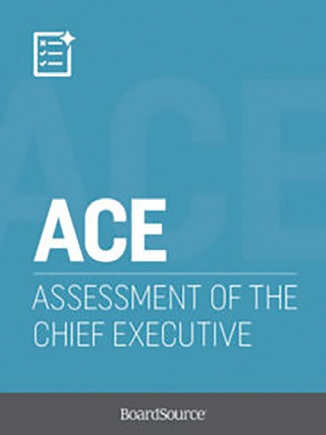

# Annual performance goals

# Core competencies

# Leadership qualities

# Accomplishments & challenges

Sample **Questions:**

The following questions are adapted from BoardSource materials:[1]

# Please indicate whether your CEO met your expectations in the following areas:

1 – Very Ineffective

2 – Ineffective

3 – Neither Ineffective nor Effective

4 – Effective

5 – Very Effective

N/A – Don’t Know

**Please add any comments about our CEO’s performance related to this core competency:**

|  |  |  |  |  |  |  |
| --- | --- | --- | --- | --- | --- | --- |
| ☑ **Board Governance and Board Relations** | **1** | **2** | **3** | **4** | **5** | **N/A** |
| 1. Our CEO’s working relationship with our board (as defined by candor, competency, trust, and integrity) is… |  |  |  |  |  |  |
| 2. Our CEO’s working relationship with our board chair (including all the key essentials for effective board meetings) is… |  |  |  |  |  |  |
| 3. Our CEO’s communication with the board (including between meetings) is… |  |  |  |  |  |  |
| 4. Our CEO’s critical role of balancing communication and information flow (including confidential information) between the board and the senior staff is… |  |  |  |  |  |  |
| 5. Our CEO’s work in supporting the board chair and our board committees by leveraging the talent and expertise of individual board members is… |  |  |  |  |  |  |

1. Adapted from “Assessment of the Chief Executive.” Accessed on August 14, 2019, *BoardSource*: *https://boardsource.org/board-support/assessing-performance/chief-executive-assessments-ace/.*